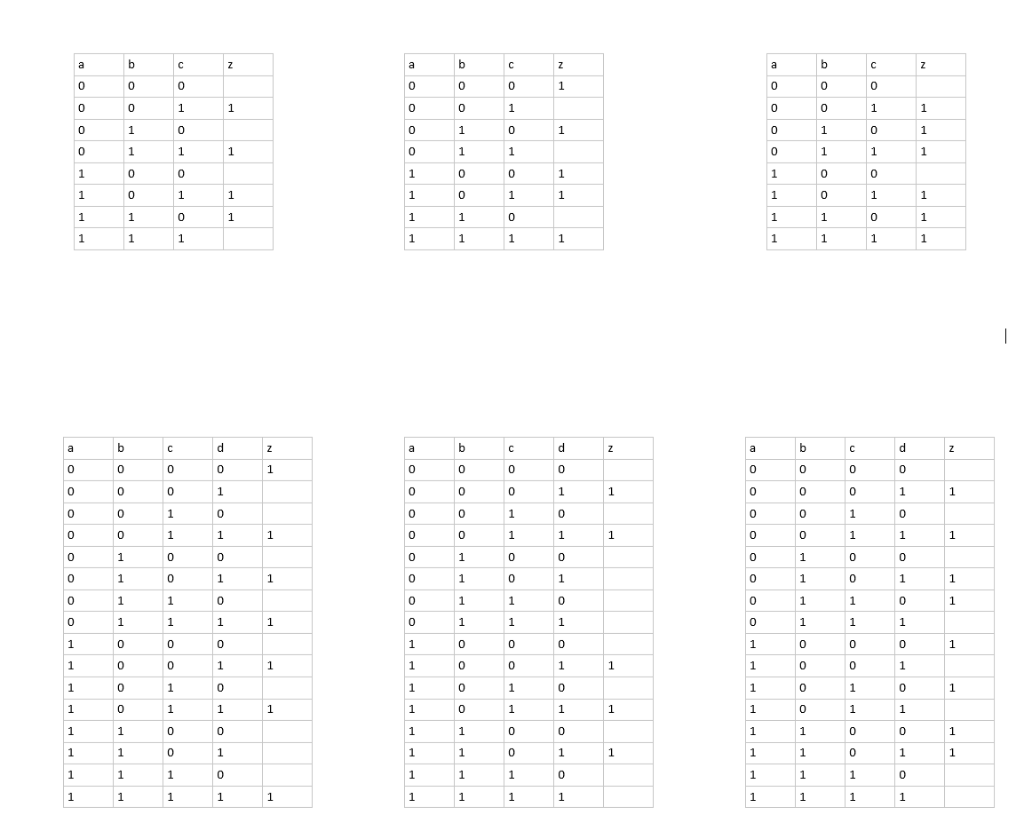

A)

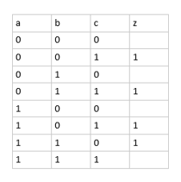

|  |  |  |  |  |
| --- | --- | --- | --- | --- |
|  | A | A | nA | nA |
| B | 8 | 7 | 3 | 4 |
| nB | 6 | 5 | 1 | 2 |
|  | C | nC | nC | C |

B)

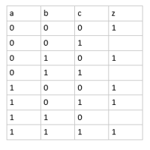

|  |  |  |  |  |
| --- | --- | --- | --- | --- |
|  | A | A | nA | nA |
| B | 8 | 7 | 3 | 4 |
| nB | 6 | 5 | 1 | 2 |
|  | C | nC | nC | C |

C)

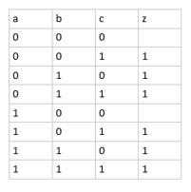

|  |  |  |  |  |
| --- | --- | --- | --- | --- |
|  | A | A | nA | nA |
| B | 8 | 7 | 3 | 4 |
| nB | 6 | 5 | 1 | 2 |
|  | C | nC | nC | C |

D)

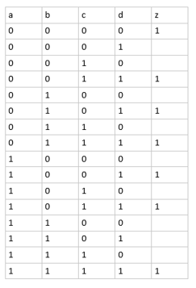

|  |  |  |  |  |  |  |  |  |  |  |  |  |  |
| --- | --- | --- | --- | --- | --- | --- | --- | --- | --- | --- | --- | --- | --- |
|  | A | A | nA | nA |  |  |  |  | nA | nA | A | A |  |
| B |  |  |  |  | D |  |  | B |  |  |  |  | nD |
| B |  |  |  |  | nD |  |  | B |  |  |  |  | D |
| nB |  |  |  |  | nD |  |  | nB |  |  |  |  | D |
| nB |  |  |  |  | D |  |  | nB |  |  |  |  | nD |
|  | C | nC | nC | C |  |  |  |  | nC | C | C | nC |  |

|  |  |  |  |  |  |
| --- | --- | --- | --- | --- | --- |
|  | nA | nA | A | A |  |
| nB |  |  |  |  | nD |
| nB |  |  |  |  | D |
| B |  |  |  |  | D |
| B |  |  |  |  | nD |
|  | nC | C | C | nC |  |

|  |  |  |  |  |  |
| --- | --- | --- | --- | --- | --- |
|  | A | A | nA | nA |  |
| B |  |  |  |  | D |
| B |  |  |  |  | nD |
| nB |  |  |  |  | nD |
| nB |  |  |  |  | D |
|  | C | nC | nC | C |  |

E)

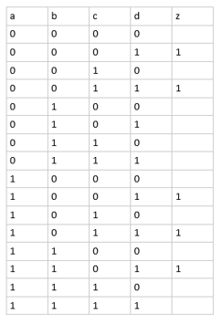

|  |  |  |  |  |  |  |  |  |  |  |  |  |  |
| --- | --- | --- | --- | --- | --- | --- | --- | --- | --- | --- | --- | --- | --- |
|  | A | A | nA | nA |  |  |  |  | nA | nA | A | A |  |
| B |  |  |  |  | D |  |  | B |  |  |  |  | nD |
| B |  |  |  |  | nD |  |  | B |  |  |  |  | D |
| nB |  |  |  |  | nD |  |  | nB |  |  |  |  | D |
| nB |  |  |  |  | D |  |  | nB |  |  |  |  | nD |
|  | C | nC | nC | C |  |  |  |  | nC | C | C | nC |  |

F)

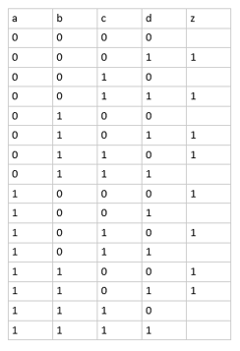

|  |  |  |  |  |  |  |  |  |  |  |  |  |  |
| --- | --- | --- | --- | --- | --- | --- | --- | --- | --- | --- | --- | --- | --- |
|  | A | A | nA | nA |  |  |  |  | nA | nA | A | A |  |
| B |  |  |  |  | D |  |  | B |  |  |  |  | nD |
| B |  |  |  |  | nD |  |  | B |  |  |  |  | D |
| nB |  |  |  |  | nD |  |  | nB |  |  |  |  | D |
| nB |  |  |  |  | D |  |  | nB |  |  |  |  | nD |
|  | C | nC | nC | C |  |  |  |  | nC | C | C | nC |  |